MiniKUbe-Setup on Linux

I — Install Minikube
- Download Minikube installer
$ curl -LO https://storage.googleapis.com/minikube/releases/latest/minikube-latest.x86_64.rpm
- Install Minikube
$ sudo rpm -Uvh minikube-latest.x86_64.rpm
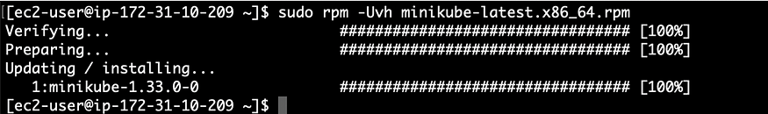
II — Install Docker
Minikube requires a container runtime to run Kubernetes and its components. Docker is the default and most widely used container runtime that Minikube relies on. Docker provides the necessary containerization technology to package applications into portable containers, as well as the tools to build, run, and manage these containers within the Minikube environment.
- Update the OS
$ sudo yum update -y
- Instance Docker :
— For “Amazon Linux 2”
$ sudo amazon-linux-extras install docker
— For “Amazon Linux 2023”
$ sudo yum install -y docker
- Add the current user (ec2-user in my case) to the docker group so that you can run Docker commands without using sudo.
$ sudo usermod -aG docker $USER && newgrp docker
- Now let’s start and enable the Docker service
$ sudo systemctl start docker && sudo systemctl enable docker
- Let’s verify whether Docker has been installed correctly :
$ docker -v
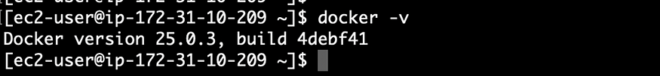
— > Docker has been installed correctly.
III — Install Kubectl
Now we need to install kubectl (Kubernetes command-line tool) with Minikube because kubectl is the primary tool used to interact with and manage Kubernetes clusters, including the Minikube cluster
Before to proceeding, it is important to confirm the version of kubectl that will be utilized. We will install kubectl using the most recent version, which aligns with the latest stable version of Kubernetes.
Let’s check the latest stable version of Kubernetes
curl -s https://storage.googleapis.com/kubernetes-release/release/stable.txt
Now use the version giving above in the URL below (in my case it is v1.30.0)
curl -LO https://storage.googleapis.com/kubernetes-release/release/v1.30.0/bin/linux/amd64/kubectl
- After that, perfom the following actions
$ sudo chmod +x ./kubectl
$ sudo mv ./kubectl /usr/local/bin/kubectl
IV — Check the results
- Now let’s start Minikube and check:
$ minikube start
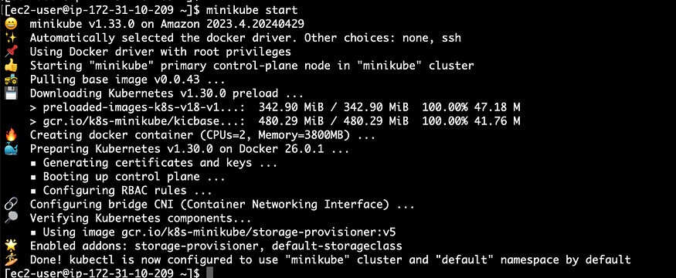
- Let’s check if kubectl is working by checking the list of pods
$ kubectl get pod -A
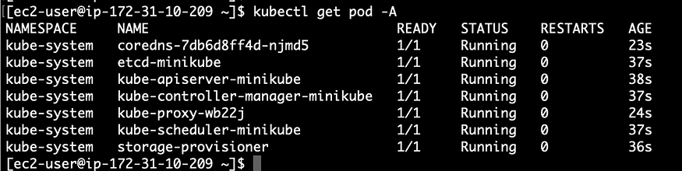
== > Everything is working correctly 😁

Lets run some basic commands on the minikube and the kubectl

minikube version
minikube version: v0.25.2
[root@dlp ~]#
kubectl version -o json

{
"clientVersion": {
"major": "1",
"minor": "10",
"gitVersion": "v1.10.0",
"gitCommit": "fc32d2f3698e36b93322a3465f63a14e9f0eaead",
"gitTreeState": "clean",
"buildDate": "2018-03-26T16:55:54Z",
"goVersion": "go1.9.3",
"compiler": "gc",
"platform": "linux/amd64"
}
}

# start minikube
[root@dlp ~]#
minikube start --vm-driver kvm2

Starting local Kubernetes v1.9.4 cluster...
Starting VM...
Downloading Minikube ISO
142.22 MB / 142.22 MB 100.00% 0s
Getting VM IP address...
Moving files into cluster...
Downloading localkube binary
163.02 MB / 163.02 MB 100.00% 0s
65 B / 65 B 100.00% 0s
Setting up certs...
Connecting to cluster...
Setting up kubeconfig...
Starting cluster components...
Kubectl is now configured to use the cluster.
Loading cached images from config file.

# show status
[root@dlp ~]#
minikube status
minikube: Running
cluster: Running
kubectl: Correctly Configured: pointing to minikube-vm at 192.168.39.110
[root@dlp ~]#
minikube service list

|-------------|----------------------|-----------------------------|
| NAMESPACE | NAME | URL |
|-------------|----------------------|-----------------------------|
| default | kubernetes | No node port |
| kube-system | kube-dns | No node port |
| kube-system | kubernetes-dashboard | http://192.168.39.110:30000 |
|-------------|----------------------|-----------------------------|

[root@dlp ~]#
minikube docker-env

export DOCKER_TLS_VERIFY="1"
export DOCKER_HOST="tcp://192.168.39.110:2376"
export DOCKER_CERT_PATH="/root/.minikube/certs"
export DOCKER_API_VERSION="1.23"
# Run this command to configure your shell:
# eval $(minikube docker-env)

[root@dlp ~]#
kubectl cluster-info

Kubernetes master is running at https://192.168.39.110:8443

To further debug and diagnose cluster problems, use 'kubectl cluster-info dump'.

[root@dlp ~]#
kubectl get nodes

NAME STATUS ROLES AGE VERSION
minikube Ready <none> 1h v1.9.4

# possible to access with SSH to the VM
[root@dlp ~]#
minikube ssh

_ _
_ _ ( ) ( )
___ ___ (_) ___ (_)| |/') _ _ | |_ __
/' _ ` _ `\| |/' _ `\| || , < ( ) ( )| '_`\ /'__`\
| ( ) ( ) || || ( ) || || |\`\ | (_) || |_) )( ___/
(_) (_) (_)(_)(_) (_)(_)(_) (_)`\___/'(_,__/'`\____)

$
hostname
minikube
$
docker ps

CONTAINER ID IMAGE COMMAND CREATED STATUS PORTS NAMES
7d769e956904 fed89e8b4248 "/sidecar --v=2 --..." 3 hours ago Up 3 ho k8s_si..
39680ff90ecf 459944ce8cc4 "/dnsmasq-nanny -v..." 3 hours ago Up 3 ho k8s_dn..
e568a2ac6088 512cd7425a73 "/kube-dns --domai..." 3 hours ago Up 3 ho k8s_ku..
fd9bd248d82f e94d2f21bc0c "/dashboard --inse..." 3 hours ago Up 3 ho k8s_ku..
f2c59bf5dd0a gcr.io/k8s-minikube/storage-prer "/storage-provisioner" 3 hours ago Up 3 ho k8s_st..
203ac12b2138 gcr.io/google_containers/pause3.0 "/pause" 3 hours ago Up 3 ho k8s_PO..
6d88074f01dc gcr.io/google_containers/pause3.0 "/pause" 3 hours ago Up 3 ho k8s_PO..
d44ea81b29f1 gcr.io/google_containers/pause3.0 "/pause" 3 hours ago Up 3 ho k8s_PO..
3b26e522321b d166ffa9201a "/opt/kube-addons.sh" 3 hours ago Up 3 ho k8s_ku..
5a0a0833416d gcr.io/google_containers/pause3.0 "/pause" 3 hours ago Up 3 ho k8s_PO..

$
exit
# to stop minikube, do like follows
[root@dlp ~]#
minikube stop
Stopping local Kubernetes cluster...
Machine stopped.
# to remove minikube, do like follows
[root@dlp ~]#
minikube delete
Deleting local Kubernetes cluster...
Machine deleted.
----------------------------------------------------

